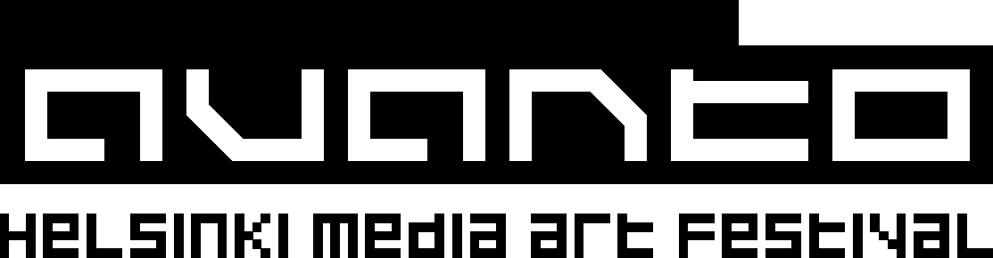

Accreditation form

Name:
Position:
Name of publication or programme:
Mailing address:

Telephone:
Email (+ Internet address):
Details of article/programme to be made:

Additional information:

Name of editor/producer/head of department:
Telephone:
Signature of editor/producer/head of department, and a stamp:

Please print and post this form to:
Avanto Helsinki Media Art Festival, Press Accreditations, PL 131, 00180 Helsinki, Finland

The deadline for accreditations is Friday 7 November!
We will contact you regarding the accreditation application by Friday 14 November.
For more info please contact press officer Milla Kontkanen
milla.kontkanen@avantofestival.com / +358 - 50 - 339 3596 / +358 - 9 - 694 1702

